Architecture

# Introduction

The Optimus dashboard mainly consists of two systems, the front-end (website) and back-end (communications back and forth with databases and data).

|  |  |  |
| --- | --- | --- |
| User | **Description** | **Permissions** |
| Guest | This is the regular user who just wishes to view data. These users are required to register in order to access the data. | Viewing data and graphs only. | |
| Developer | Developers are able to view data as well as adding data to their projects. They can also import a full list of stored data. | Viewing data and graphs.  Adding data.  Importing data. |
| Admin | An admin has the same controls as the developer as well as the ability to manage user profiles. | Viewing data and graphs.  Adding data.  Importing data.  Managing user accounts (reset password, update permissions, delete user) |

**State Diagram**

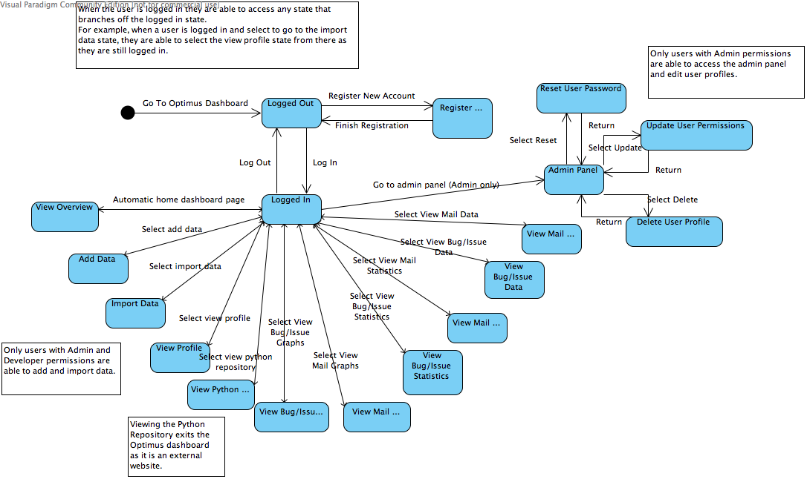

# Register New Account

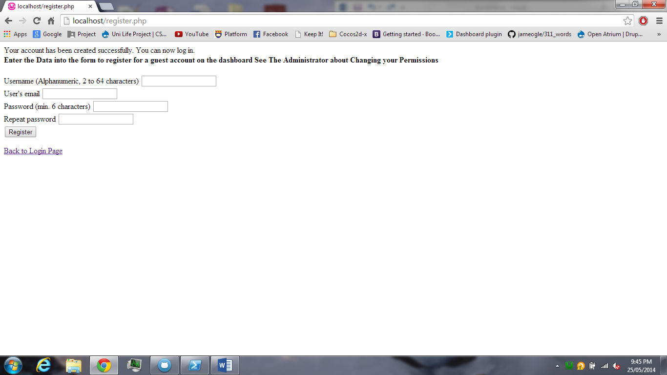

When you first arrive at the Optimus dashboard website you are prompted to register a new account. When selecting this option you are taken to this page that allows you to enter in a preferred username, your email and a password (along with password confirmation). This information is then sent to the user database which is where it will be saved. Once the user has registered they will then be automatically returned to the log in screen.

**Sequence Diagram**

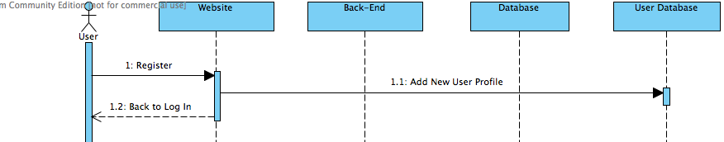

# Log In Page

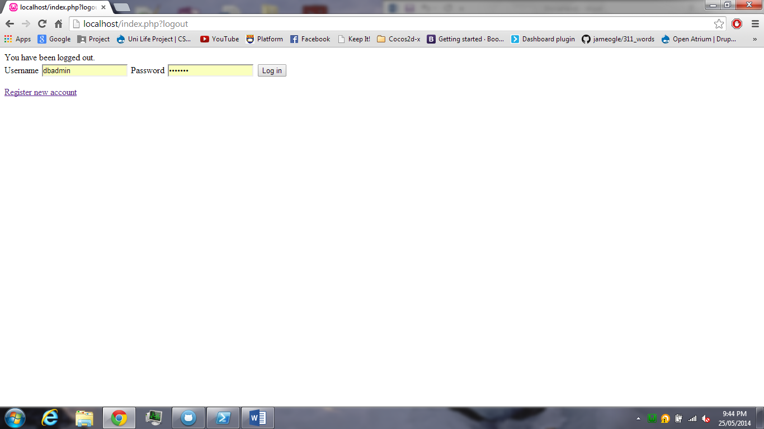

Assuming the user has an account they are now able to log in to the Optimus dashboard by typing out their username and password (hidden). Then selecting the “Log in” button. If the username and password combination they entered does not match any profiles stored in the user database, then they will be automatically returned to the log in page. If the username and password combination is correct then the user will be granted access to the Optimus dashboard and they will be automatically taken to the home page, which provides an overview of all the data currently imported into the system. This data is taken

**Sequence Diagram**

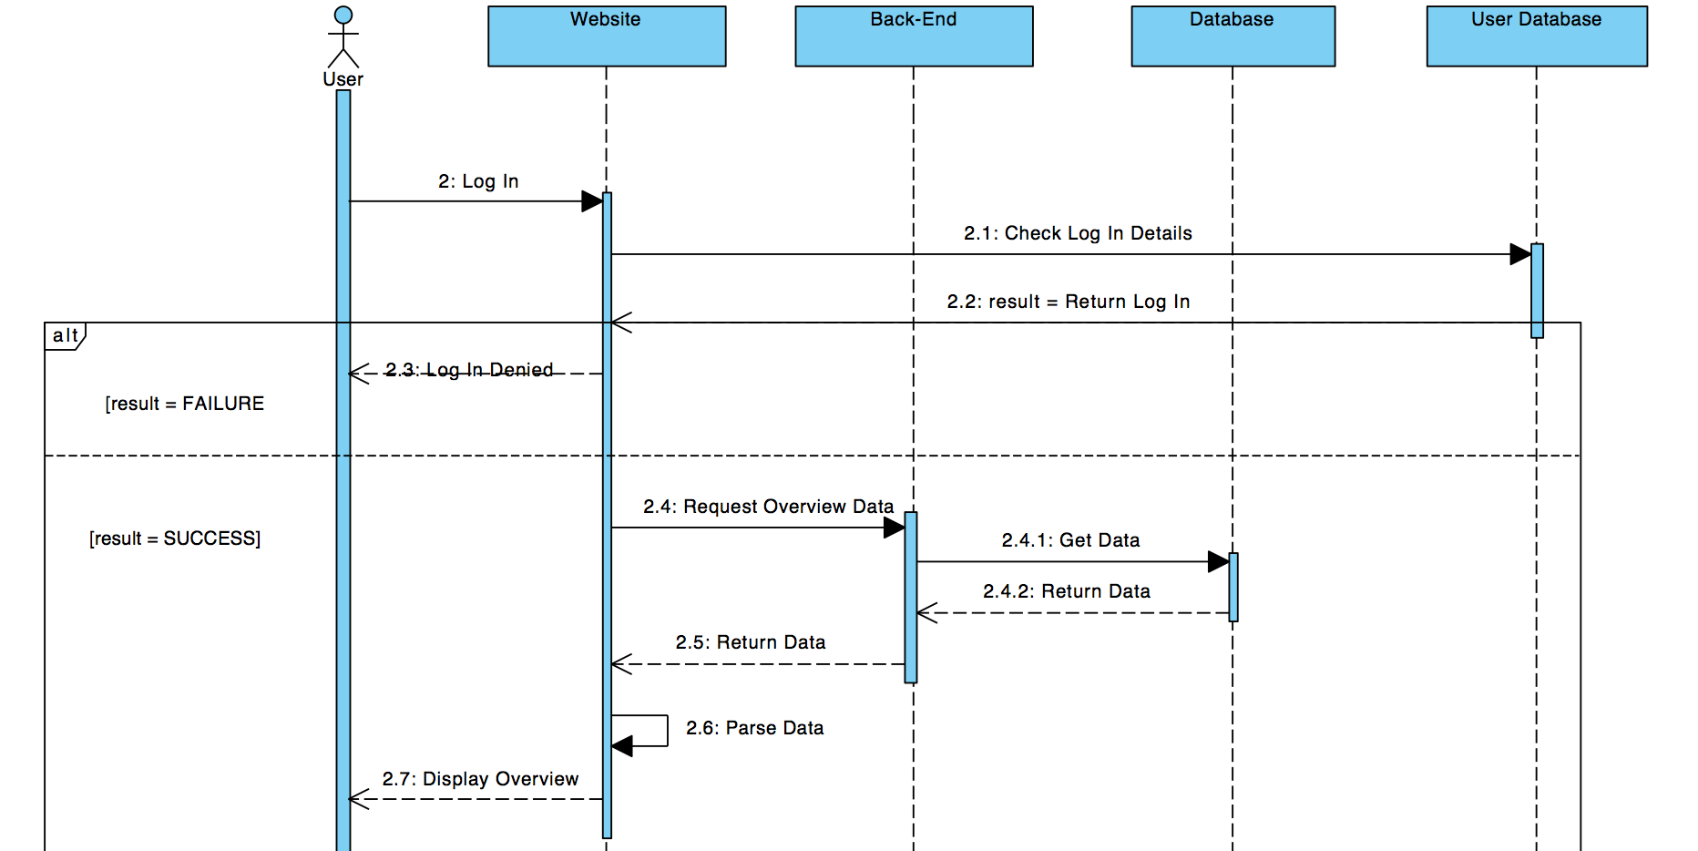

# Home (overview)

# 

Paragraph

# User Profile

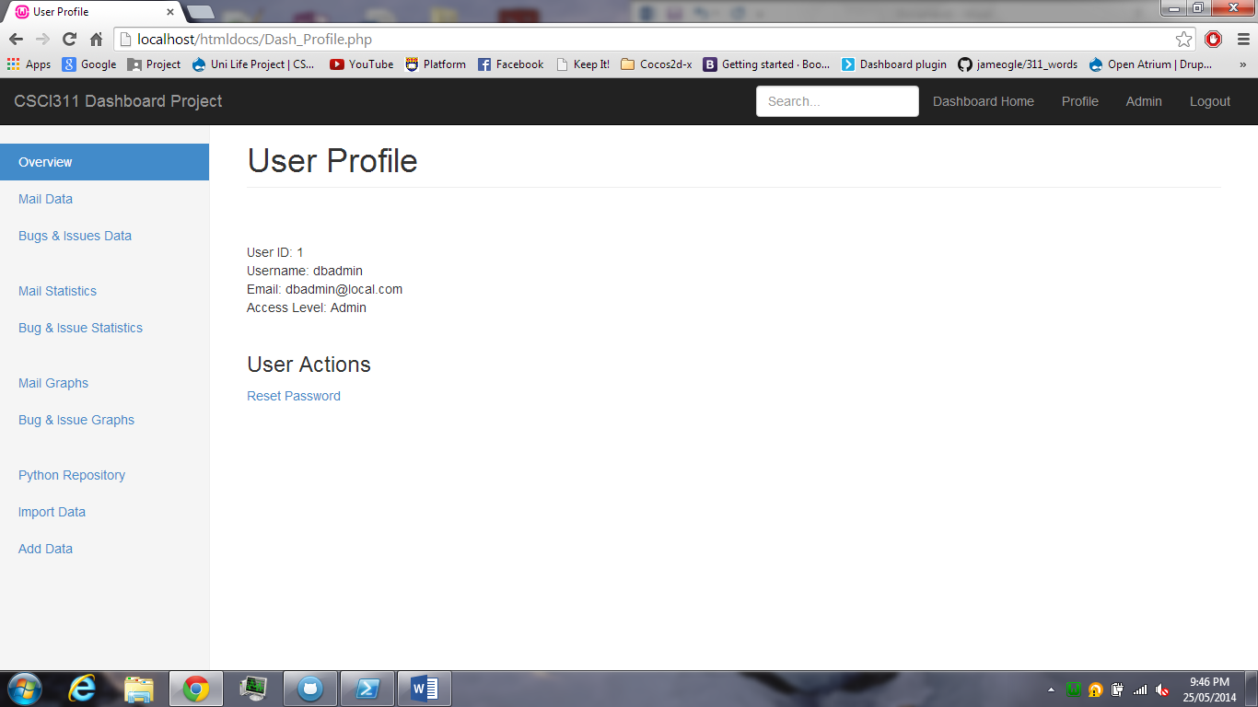

**Sequence Diagram**

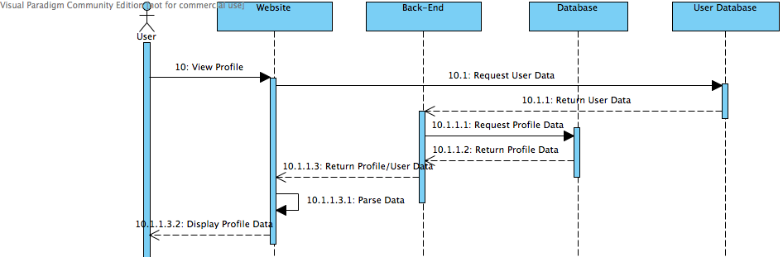

# Admin Menu

Paragraph

**Sequence Diagram**

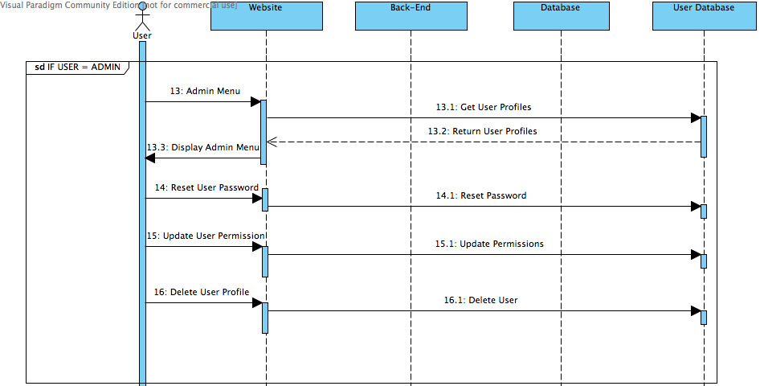

# Mail Data

Img

Paragraph

**Sequence Diagram**

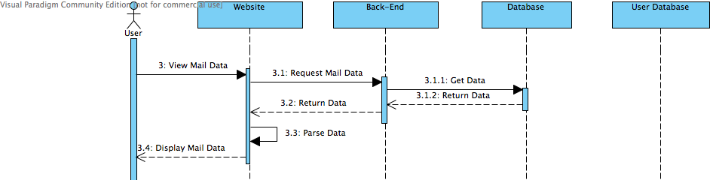

# Bug and Issue Data

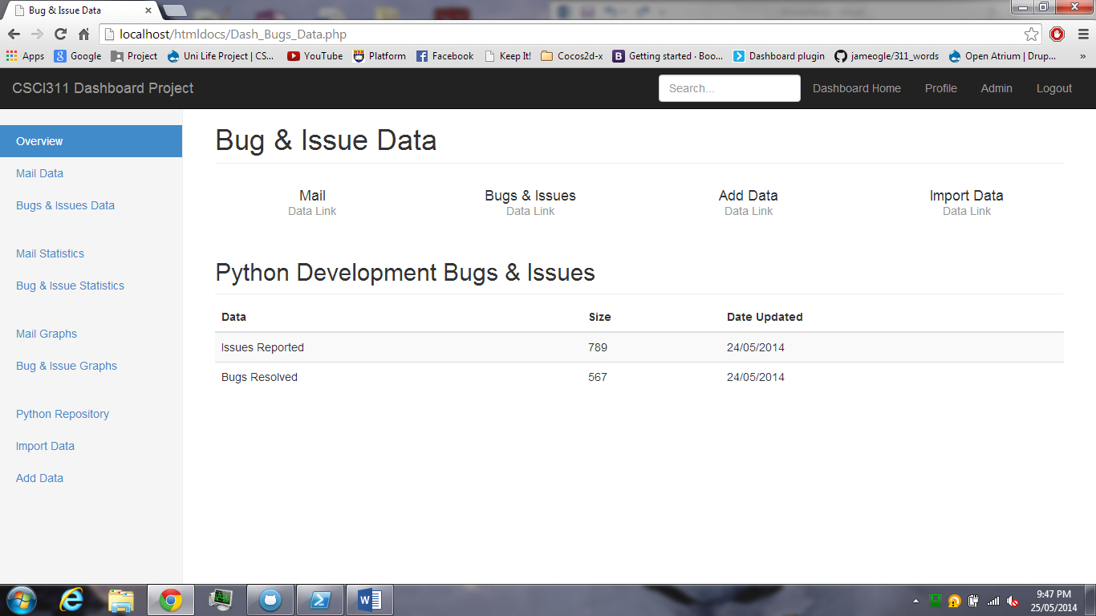

Paragraph

**Sequence Diagram**

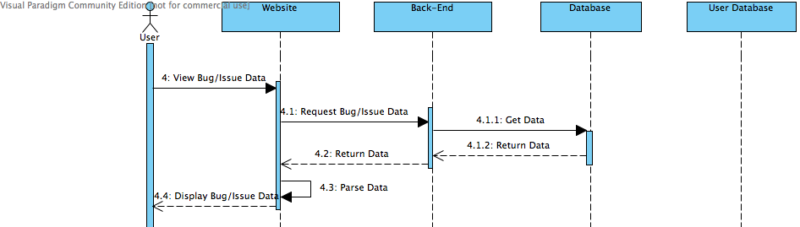

Mail Statistics

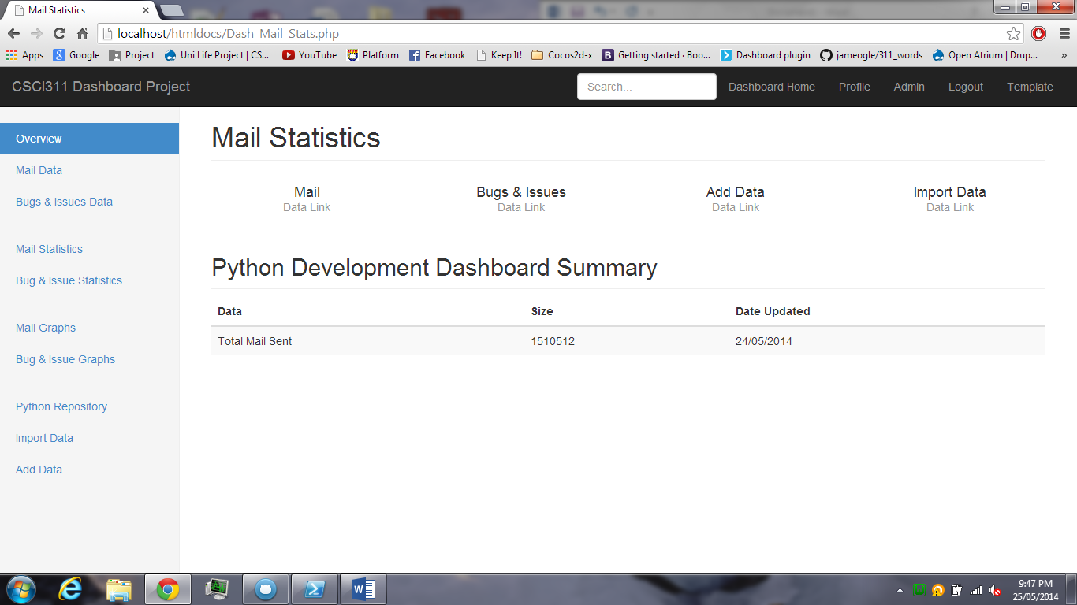

Paragraph

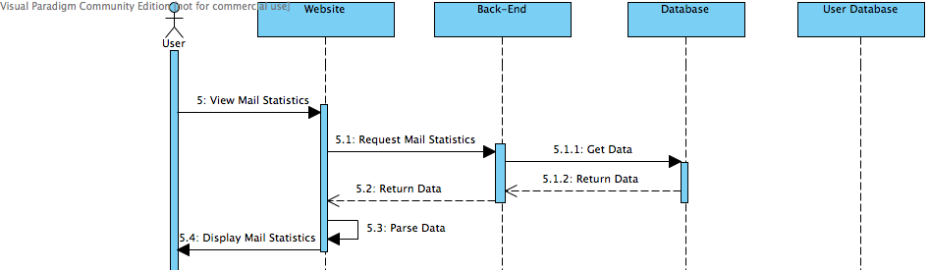**Sequence Diagram**

# Bug and Issue Statistics

Paragraph

**Sequence Diagram**

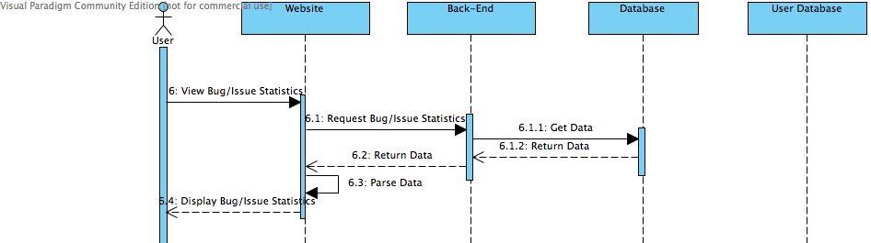

# Mail Statistics Graphs

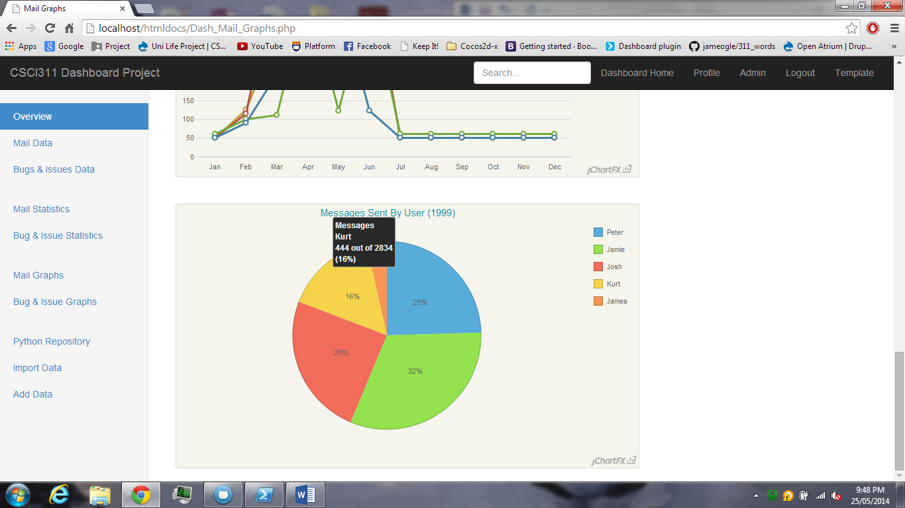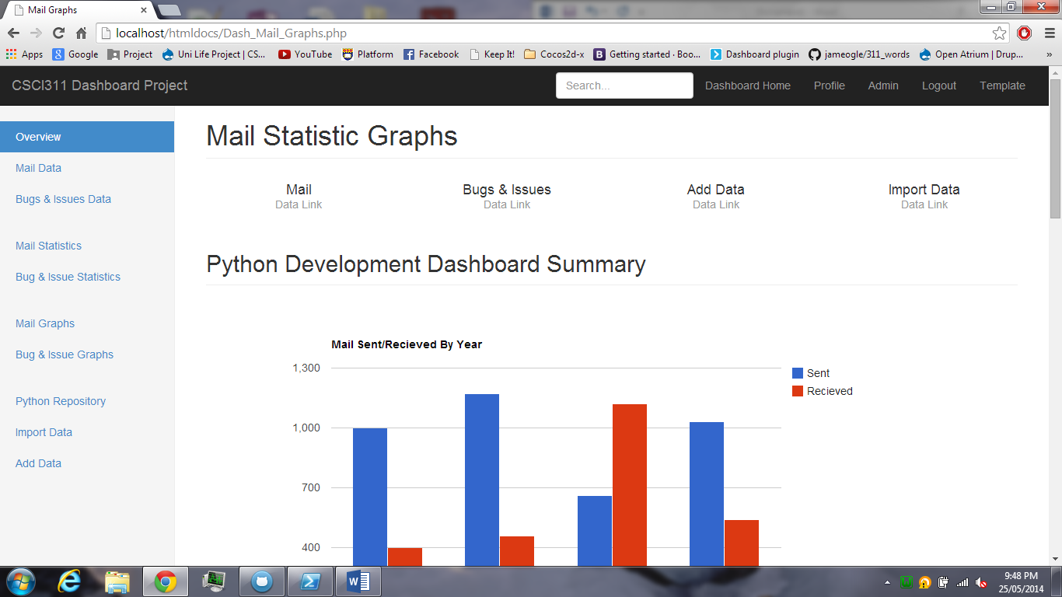

Paragraph

**Sequence Diagram**

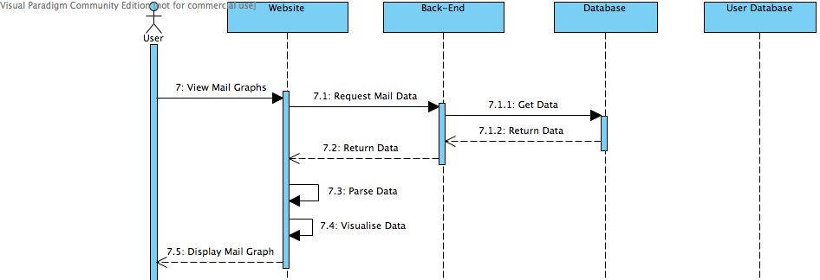

# Bug and Issue Graphs

Img

Paragraph

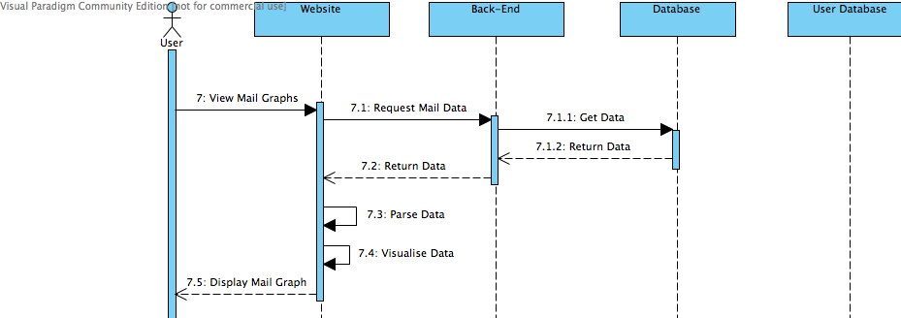**Sequence Diagram**

# Python Repository

Img

Paragraph

**Sequence Diagram**

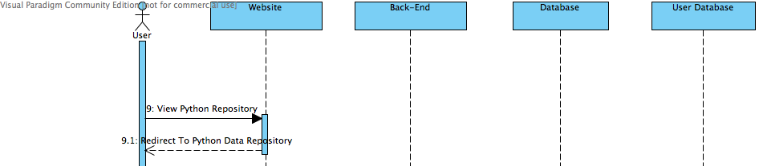

# Import Data

Img

Paragraph

**Sequence Diagram**

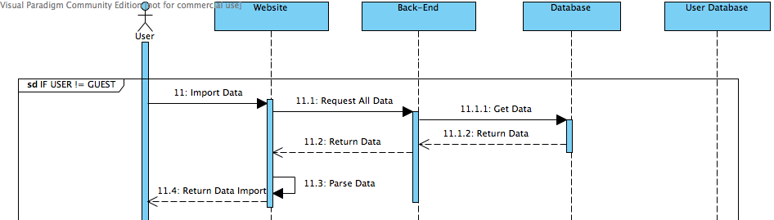

# Add Data

Img

Paragraph

**Sequence Diagram**

